# **Vehicle Parking Management System**

##### **Authors: Danish A. Khan, Darshan A. Chavan, Himanshu M. Baviskar, Rahul D. Pardesi, and Pushkar P. Shinde**

#### **Abstract:**

The number of vehicles and traffic is increasing exponentially day by day, due to which automatic vehicle identification and monitoring systems are becoming increasingly important all over the world.

The Vehicle Parking Management System is an automated solution that allows for efficient management of parking spaces and tracking of vehicle and owner information. It uses sensors and software to monitor the vehicle owner's information as well as the availability of parking spots, reducing the time and effort required to manage the vehicle.

Different countries in the world are using various types of automatic systems for traffic control and vehicle identification. Number plate recognition (NPR) is an authentic-time embedded system that frequently recognises the number plate of a vehicle. Previous systems were used only for the identification of vehicles. The proposed system involves using RFID (radio frequency identification) for the identification and verification of vehicles. RFID technology allows for more accurate and efficient identification of vehicles, reducing the likelihood of errors or fraud in the verification process. Additionally, the use of RFID can also enable real-time tracking and monitoring of vehicles, improving overall security and management.

Keywords: RFID tags, smart parking systems, Internet of Things (IOT),

1. **Introduction**:

A vehicle management system using RFID (radio frequency identification) technology is a sophisticated system that can streamline and improve the efficiency of vehicle tracking, monitoring, and control in various applications, such as the identification and verification of vehicles and parking lots.

The system consists of RFID tags that are attached to vehicles, RFID readers that are installed in parking lots, and a smart parking software application that manages the data collected by the readers. The RFID tags transmit a unique identifier that can be read by the readers, which in turn send the information to the software application. The smart parking software then processes the data, generating reports and alerts that can be used to manage the parking lot and optimise operations.

With a vehicle management system using RFID and smart parking technology, vehicle owners can easily find that a parking lot is available, reducing the time and frustration associated with searching for a parking spot. Parking lot operators can use the system to manage parking capacity, optimise usage, and reduce congestion, leading to a more efficient and profitable operation. The system can also improve security by monitoring the entry and exit of vehicles and reducing the risk of fraud or unauthorised access.

The vehicle management system provides access to and management of different vehicles for students, teachers, faculty, and visitors. Our project is based on RFID scanning and reading, which stores and maintains the information of different vehicles within the system. The advantage of the management system is that we’ll be able to track the number of vehicles entering the campus.

Following are the objectives of the proposed work:

1. Using RFID technology, create an efficient automatic authorised vehicle identification system.
2. Track the incoming and outgoing vehicles and separate the vehicles of the staff, students, and visitors.
3. We will also get information about the owner of the vehicle and all the details of the vehicle.
4. If an unauthorised vehicle tries to enter the premises, it will automatically activate the buzzer or beeper, which is an audio device.
5. The system helps reduce the time and effort required to locate a parking spot, resulting in a determination of whether a parking spot is available or not.

#### **LITERATURE REVIEW :**

The most important and also worrying portion of any number plate recognition system is that the recognition and extraction of the vehicle number directly affect overall system accuracy. The presence of noise, distortions within the image, irregular illumination, blurred images, and foggy environments make the job even tougher. During this work, we tend to suggest a different technique for having the police correctly investigate the vehicle number plates. The projected system will work very correctly in any atmosphere, daytime, or circumstance. There are certain foreign, national, or native standards for vehicles. In China, the fundamental standards [12] for the volume plate are assumed. Certain native cooperatives, like European Public (EU), have number plates that outline the country, the place of registration, etc. During this text, Chinese, Pakistani, and Kuwaiti number plates are coated. The problem of automatic NPR was discussed later in the 1990s [5], [8], and [10]. The captured image is first processed to enhance and improve boundary line information by using algorithms such as the gradient filter, leading to a picture shaped by edges. The image so processed is reborn as its binary matching half after being processed by sure algorithms, like Hough rework, to observe lines. Eventually, pairs of 2-parallel lines were thought of as a plate [6], [11]. Alternative techniques supported the morphology of substances in a picture [1], [7]. This technique focuses on certain relevant properties of car plate pictures, like their illumination, contrast, regularity, positions, etc. Due to these options, this technique might be used to notice the parallel properties in a very clear image and find the location of variety plate areas. The third technique was supported by the applied math properties of text [3] and [4]. During this method, text regions were exposed to mistreatment and math properties of text, just like variance of grey level, variety of boundaries, edge thicknesses within the area, etc. This approach was unremarkably utilised in finding text in pictures and will rather be used for locating and designating candidate variety plate areas as they embrace letters and numbers. There are a variety of different approaches to this downside, specialising in police investigation, NPR mistreatment computing, and genetic algorithms [2], [9]. These systems used edge observation and edge information, as well as artificial intelligence techniques, to detect the position and amount of plate space. All systems mentioned above have some limitations; as an example, they're plate size dependent, colour dependent, and only work in certain conditions or atmospheres similar to indoor pictures, etc. The tactic that we tend to suggest is the freeing up of the colour, size, location, and position of the number plate of the vehicle. A lot of studies and different approaches have been suggested. The major work is done on plate localization, which is precise for the NPR area. But they have not studied verification and extraction in the same system. The model implementation expected a clear number plate text, and more tests need to be shown on this system. The text extraction process involves the localization, improvement, and recognition of text blocks in a given image. Number plate recognition (NPR) systems can be recognised as an application of text information extraction (TIE) algorithms. As the application is specific to number plate images, the NPR text extraction process can leverage particular visual features and constraints. Different methods have been proposed for NPR text extraction, and each uses a specific set of perceptible features to emphasise the text areas.

**Proposed System Prototype:**

A prototype is a rudimentary working model of a product or information system, usually built for demonstration purposes or as part of the development process. Figure 1.0 shows the main interface of the system. It shows the screen for admin login, where authorised people are allowed to login. Authorised people can also do vehicle registration and access the detailed information about the vehicle.

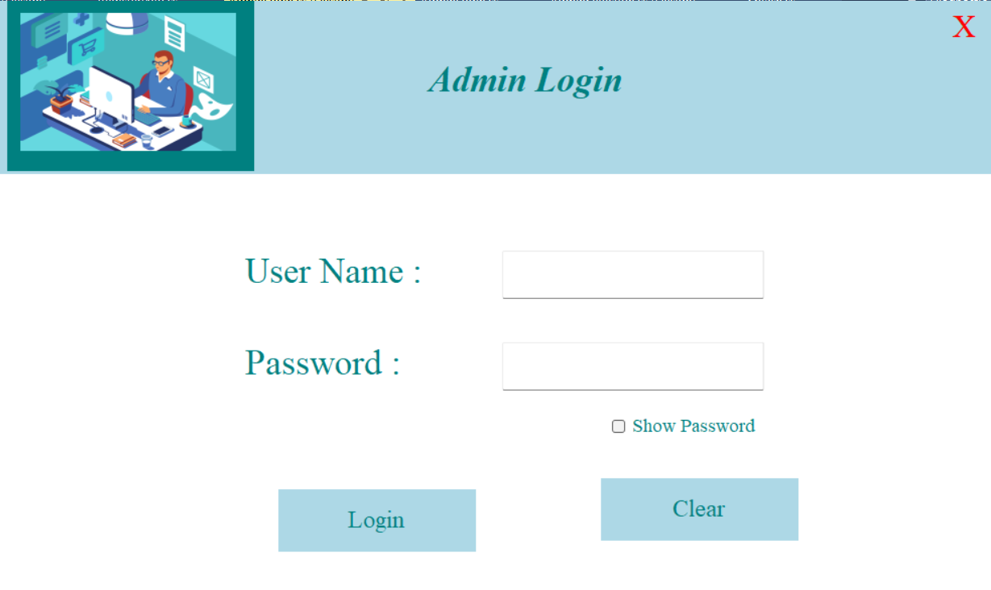

On the other hand, Figure 2.0 shows the screen for the registration form; it displays the registration information such as the user's or owner's name, vehicle number plate,type of vehicle,contact number, role of the vehicle, i.e., is it a student vehicle or a staff vehicle, as well as the profile of the owner. This form will serve as a monitoring tool for the registered vehicle and authorised owner that enter the campus

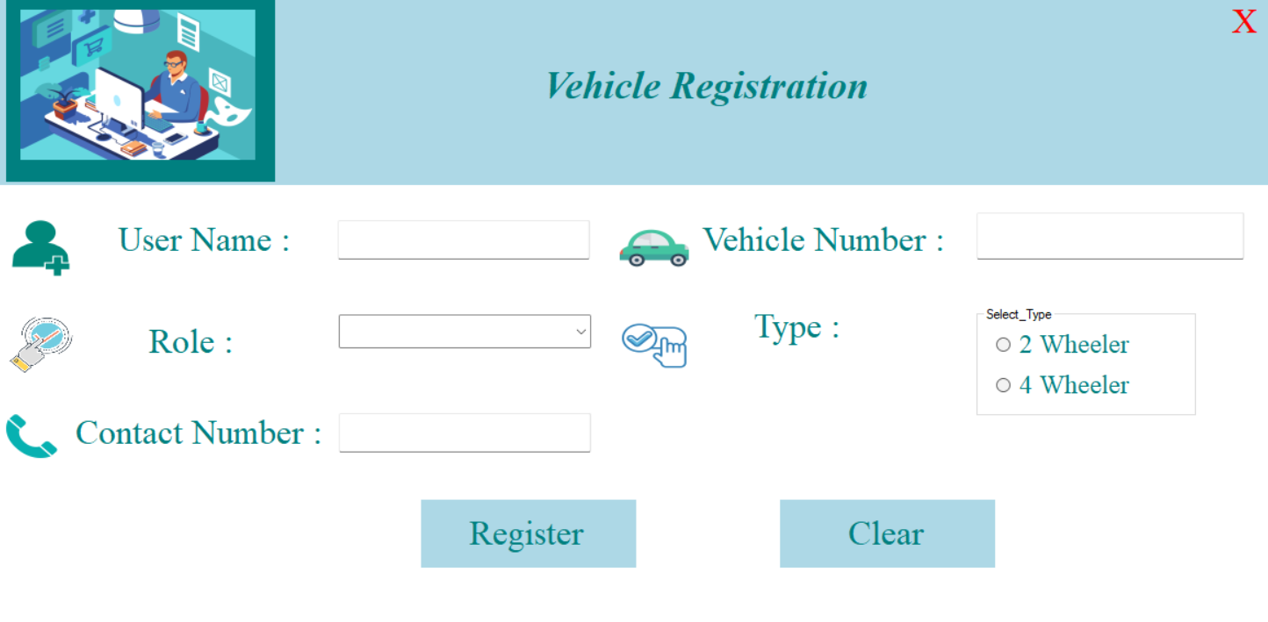

#### **Software Implementation :**

The proposed parking system consists of the following two segments, each of which is interrelated with the other: The next segment works in accordance with a proper analysis of the results from the previous segment. The two segments are explained as follows:

**Parking Entry System:**

This module contains parking gates embedded with RFID sensors. The moment a vehicle comes near these gates, the RFID sensor senses the RFID tag on the vehicle and records all the information related to the vehicle, storing that information in the Firebase Cloud. At exit time, the parking gates read the RFID tags again and update the information.

**Overall performance:**

A vehicle parking management system delivers the flexibility, scalability, and responsiveness that today's organisations need. It requires installing RFID tags on all vehicles and RFID readers at various junctions for tracking. It aimed to track vehicles that passed through the gate and also provided a complete screening process for security requirements and assisted in ensuring safety, which can be used more easily and effectively. Based on the results of the survey, it is useful because it can assist and facilitate the process of vehicle tracking, especially for security. It is required to assist with safety and can be used more easily and effectively. It is also needed to assist security officers in doing their daily tasks with ease and efficiency. It was developed according to the needs of users through careful planning and analysis. In light of this study, it focuses on the transformation of the current manual system for accepting registration from the vehicle owner and monitoring the vehicles that enter the campus. The purpose of the system is to provide a repository for all registered vehicle owners on campus. Whenever a vehicle is entered into the organisation, the in and out times are noted automatically by the RFID device, which uses the registered RFID tag as a car pass. It is in this context that this paper sought to design a prototype and develop a computer-based system that is able to provide real-time information through RFID technology to students, faculty, and staff regarding their registration and the monitoring of registered vehicles that enter and exit the campus. It further aimed to determine the level of usability of the developed features of the vehicle management system using RFID and also evaluate the performance of the vehicle management system using RFID in terms of reliability, functionality, and efficiency of the information provided to clients.

**References:**

1. Durani, A. M., Ali, M., Ahmad, R., Irfan, S., and Ur Rehman, H. (2016). Identification and verification of vehicles using RFID techniques *VAWKUM Transactions on Computer Sciences*, *10*(2), 1–8 [1]
2. Ng, K. L., Chiong, C. W., & Reine, R. (2019, April). Vehicle Recognition System Using RFID Technology for Parking Management System in *IOP Conference Series: Materials Science and Engineering* (Vol. 495, No. 1, p. 012022), IOP Publishing [2]
3. More, V., Ravariya, K., Shah, S., & Solkar, A. (2017). Automatic Car Parking System using RFID, *International Journal of Engineering Science and Innovative Technology (IJESIT), Volume 4*, *[3*]
4. Pathak, Abhijit, Abrar Hossain Tasin, Md. Shahid Uddin Rahat, Vicky Barua, Munna Das, and Sudarshan Das, "Cloud-Based Smart Parking Systems Using IoT," in *Applied Informatics for Industry 4.0*, pp. 1–10, 6000 Broken Sound Parkway NW, Suite 300, Boca Raton, FL 33487–2742: CRC Press, 2023. [4]

​